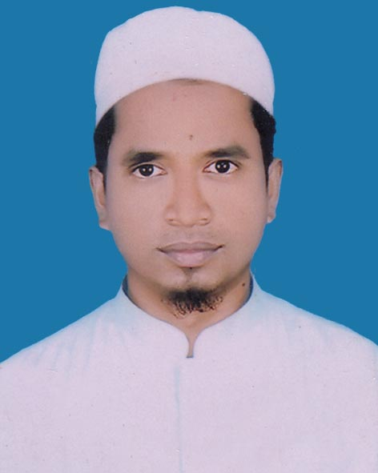

**Resume Of**

**Mohammad Israfil**

Vill: Dadpur, Post: Ramballavpur

P.S: Noakhali Sadar, Dist: Noakhali

Mobile: 01816675221

E-mail: misrafil178@gmail.com

**Objective** : To build up a respectable career in a reputed institute where I can be able to prove my competence.

**Education** **B.B. S (Honours)**

University : National University

Subject : Accounting

Year : 2012

Result : 2nd Class

**Higher Secondary Certificate(H.S.C)**

Board : Comilla

Group : Business Studies

Year : 2008

Result : 3.90

**Secondary School Certificate(S.S.C)**

Board : Comilla

Group : Business Studies

Year : 2006

Result : 3.31

**Language**  : Bengali : Excellent

**Proficiency** : English : Good

**COMPUTER KNOWLEDGE :**

a) Package **:** MS-Word, Ms-Excel, Ms-Power Point, Office XP

b) Others  **:** E-mail use, Internet Browsing etc.

**HOBBY & INTEREST** : Internet Browsing, to introduce a new person with sound understanding.

**AS A INDIVIDUAL :◈** Ability to meet deadlines.

**◈** Ready to cope up with new challenging environment.

**◈** Good in Public relation, excellent communication skill.

**◈** Willing to learn, enthusiastic, able to take initiative and

Capable to work under pressure.

**Personal Details:**

Father’s Name : Nur Nobi

Mother’s Name : Peara Begum

Permanent Address : Vill: Dadpur, Post: Ramballavpur

P.S: Noakhali Sadar, Dist: Noakhali-3834

Date of Birth : 25 December 1989

Nationality : Bangladeshi (by birth)

Religion : Islam

Marital Status : Single

Blood Group : A+ve

Home District : Noakhali

**Reference:**

|  |  |
| --- | --- |
| Md. Delwar Hossain | Anupom Chandra Das |
| Head of the dept. of Accounting | Associate Professor |
| Chowmuhani Govt. S.A College | Department of Accounting, |
| Noakhali. | Noakhali Govt. college |
| Cell:01813-122118 | Cell: 01716674707 |

**Declaration of Authenticity**

|  |
| --- |
| I do hereby declare that all information have presented are true to my knowledge, If required and where applicable, this document can be supported by appropriate authentic certificates or papers. |



-----------------------------

(Mohammad Israfil)

Date: